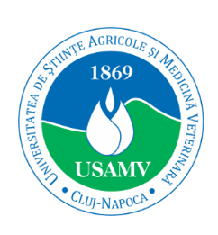

**Department of Transversal Competencies**

**University of Agricultural Sciences and Veterinary Medicine of Cluj-Napoca**

**Conference Programme**

The International Conference on Transversal Education (ICTE), 1st edition

“Transversal Perspectives in Education - Skills for the Future”

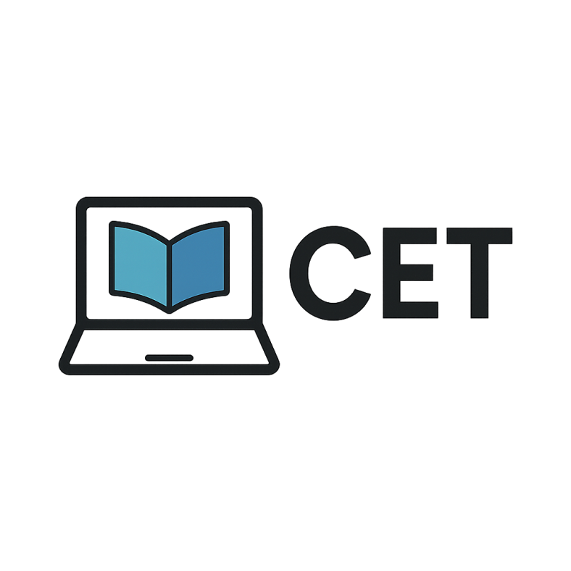

the 20th of June, 2025

**Official Opening Ceremony and Plenary Speeches**

The Red Amphitheatre (https://maps.app.goo.gl/VoBwev7W33mSCwei8)

9:30-10:00 – Registration

10:00-10:30 – Official opening, welcoming speech

* Professor Vlad MUREȘAN, PhD – Vice-rector for academic research, University of Agricultural Sciences and Veterinary Medicine of Cluj-Napoca;
* Professor Ioana ROMAN, PhD – Head of Department of Transversal Competencies, University of Agricultural Sciences and Veterinary Medicine of Cluj-Napoca.

10:30-12:00 – Plenary speeches

* Professor Mușata BOCOȘ, PhD - “Babeș-Bolyai” University, Cluj-Napoca, The Faculty of Psychology and Education Sciences  
  Title: Reflections and problematics of general and special didactics
* Lecturer Elena PĂCURAR, PhD - “Babeș-Bolyai” University, Cluj-Napoca, The Faculty of Letters

Title: What's ethics got to do with AI literacy?

12:00-12:30 – Coffee break

12:30-14:00 – Panel 1, onsite sections

14:00-15:00 – Lunch

15:00-16:30 – Panel 2, online sections

18:00 – Cluj-Napoca guided tour

**Foreign Languages Section**

**PANEL 1: 12:30-14:00 (onsite)**

1. **Germanic languages: English language and German language**

Moderator – Associate professor Mihaela MIHAI, PhD

Room DPPD IV, ground floor, DPPD (https://maps.app.goo.gl/5dJvZxyYzrdvF5J38)

* **Associate professor Simona AVARVAREI**, PhD, Iași University of Life Sciences „Ion Ionescu de la Brad”

Tailoring English for Specific Purposes for Life Science Students: A Needs Analysis Case Study

* **Lecturer Zoica BĂLĂBAN, PhD,** “Babeș-Bolyai” University, Cluj-Napoca

Supporting (Business) Students in Developing their Vocabulary with the Help of LexTutor.ca

* **Lecturer Mona TRIPON, PhD**, Technical University, Cluj-Napoca

KI im Fachsprachenunterricht (AI in Teaching Language for Specific Purposes)

* **Assistant Emanuel SĂRMĂȘAN, PhD** - “George Emil Palade” University of Medicine, Pharmacy, Science, and Technology of Târgu Mureș

Zwischen Tradition und Modernität. Begreifen durch liebende Anschauung in der religiösen Dichtung

* **Lecturer Anca MOANGĂ, PhD**,Associate professor Mihaela MIHAI, PhD, Lecturer Narcisa ALBERT, PhD, University of Agricultural Sciences and Veterinary Medicine of Cluj-Napoca

Fremdsprachenunterricht an den siebenbürgischen Schulen in der Zwischenkriegszeit (Foreign language teaching in Transylvanian schools during the interwar period)

* **Associate professor Mihaela MIHAI, PhD**, Lecturer Narcisa ALBERT, PhD, Associate professor Anca URSA, PhD, Professor Diana DUMITRAȘ, PhD, University of Agricultural Sciences and Veterinary Medicine of Cluj-Napoca

Learner - internal and learner-external motivations for ESP classroom enjoyment and engagement

* **Lecturer Narcisa ALBERT, PhD**,Associate professor Mihaela MIHAI, Associate professor Anca URSA, PhD, Professor Diana DUMITRAȘ, PhD, University of Agricultural Sciences and Veterinary Medicine of Cluj-Napoca

An inclusive contextualized analysis on the intrinsic connection between EFL/ESP content and methods, level of English and learning outcomes

1. **Romance languages: RLF (Romanian Language for Foreigners) and FLFL (French Language as a Foreign Language)**

Moderator – Associate professor Anca URSA

Room DPPD II, 2nd floor, DPPD (https://maps.app.goo.gl/5dJvZxyYzrdvF5J38)

* **Lecturer Emina CĂPĂLNĂȘAN, PhD**, West University of Timișoara

Accentul în limba română - o provocare pentru străini? (The Issue of Accent in Romanian. A Challenge for Foreigners)

* **Member of the teaching staff**, Maria SIMINA-SUCIU, PhD “Babeș-Bolyai” University, Cluj-Napoca

Analiza discursului în Româna pentru scopuri specifice (Discourse Analysis for Romanian for Specific Purposes)

* **PhD student** Andreea BEATRIX PANTILOI, “Babeș-Bolyai” University, Cluj-Napoca

Challenges in building an oral ”micro language” Corpus in RFL (CoMLo). Between discursive reality and methodological constraints

* **PhD student Ioana MARIAN**, “Babeș-Bolyai” University, Cluj-Napoca

Evaluarea formativă a producțiilor scrise în procesul de achiziție a limbii române ca L2: Abordare aplicată în context medical universitar (Formative Assessment for Written Messages in the Language Acquisition Process of Romanian as L2. An Applied Perspective for the Medical Academic Context)

* **Member of the teaching staff** Angela POP, PhD, University of Agricultural Sciences and Veterinary Medicine of Cluj-Napoca

Discours kaléidoscopiques dans l’enseignement-apprentissage du FLE

* **Associate professor Anca URSA, PhD**, Associate professor Mihaela MIHAI, PhD, Lecturer Narcisa ALBERT, PhD University of Agricultural Sciences and Veterinary Medicine of Cluj-Napoca

Cartografierea imaginarului digital. O analiză calitativă a percepțiilor studenților asupra AI în învățarea limbilor străine (Mapping Digital Worlds. A Qualitative Analysis of Students’ Perceptions on AI for Learning Foreign Languages)

**PANEL 2: 15:00-16:30**

**online, link Google Meet: https://meet.google.com/svy-hqin-ccn**

Moderator – Lecturer Narcisa ALBERT, PhD

Room DPPD IV, ground floor, DPPD (https://maps.app.goo.gl/5dJvZxyYzrdvF5J38)

* **Associate professor Raluca GHENȚULESCU**, PhD, Technical University of Civil Engineering, Bucharest

The Role of Specialized Languages in F. Scott Fitzgerald's Novels

* **Assistant Erion SHEHU**, P**hD student**, Associate professor Mihaela MIHAI, PhD, Assistant Enxhi SHEHU, Agricultural University of Tirana, Albania, University of Agricultural Sciences and Veterinary Medicine , Cluj-Napoca, Romania

Unveiling ESP Skill Profiles among Albanian Informatics Undergraduates: A Ward–K-Means Cluster Analysis

* **Member of the teaching staff** **Antonia DINU**, Technical University of Civil Engineering, Bucharest

Comment traduire l’humour : le défi qui ne fait pas sourire les traducteurs (How to translate humour: a challenge that doesn't make translators smile)

* **PhD student** **Olivia ȚÎRLEA**, “Babeș-Bolyai” University, Cluj-Napoca

„Pe stradă sau la Zoo?”. Despre cuvinte românești mai puțin plăcute pe care le poate auzi un vorbitor nonnativ (“On the Street or at the Zoo?” About Less Pleasant Romanian Words that a Non-native Speaker May Hear”)

**Psychopedagogy Section**

**PANEL 1: 12:30-14:00 (onsite)**

Moderator – Lecturer Adela Simina LUCACI, PhD

Room DPPD I, 2nd floor, DPPD  
(https://maps.app.goo.gl/5dJvZxyYzrdvF5J38)

* **Lecturer Cristina BĂLAȘ BACONSCHI**, Associate professor Andrea Hathazi, PhD, Associate professor Carolina BODEA HAȚEGAN, PhD, “Babeș-Bolyai” University, Cluj-Napoca

Rolul serviciilor și programelor de sprijin centrate pe student: perspective și experiențe ale studenților cu dizabilități (The role of student-centred support services and programmes: perspectives and experiences of students with disabilities)

* **Associate professor Carolina BODEA HAȚEGAN1, PhD**, LecturerDorina Talaș1, PhD, Lecturer Carmen COSTEA-BĂRLUȚIU1, PhD, Associate professor Andrea Hathazi, PhD, Assistant Raluca Trifu2, PhD, Lecturer Cristina BĂLAȘ BACONSCHI1

1“Babeș-Bolyai” University, Cluj-Napoca

2 “Iuliu Hațieganu” University of Medicine and Pharmacy, Cluj-Napoca

Dimensiunile comunicării în cadrul relației terapeutice: impact și aplicații psihopedagogice (The dimensions of communication in the therapeutic relationship: impact and psycho-pedagogical applications)

* **Assistant Alexandra CĂLUGĂR**1, **PhD**, Lecturer Mirela FĂRĂGĂU-DRAGOȘ1, PhD, Lecturer Tunde GIURGIUMAN1, PhD Lecturer Adela-Simina LUCACI1, PhD, Camelia ALĂMOREAN1, PhD, Assistant Mara-Grația DEZMIREAN1,2, PhD student

**1**University of Agricultural Sciences and Veterinary Medicine of Cluj-Napoca

2“Babeș Bolyai” University, Cluj-Napoca

Intervention Strategies for Problematic Smartphone Use: Enhancing Emotional Regulation and Self-Control

* **Lecturer Carmen COSTEA-BĂRLUȚIU1, PhD**, Laura Elena RUNCEANU2, Affiliated researcher

1“Babeș Bolyai” University, Cluj-Napoca

2Jönköping University, School of Education and Communication, Research Group Communication, Culture and Diversity, Jönköping, Sweden

Percepții ale cadrelor didactice universitare cu privire la conceptul de ableism în mediul academic din România (Perceptions of university teaching staff regarding the concept of ableism in the academic environment in Romania)

* **Lecturer Editha-Margareta Cosarba**, Aurel Vlaicu University, Arad Competența socială la copiii supradotați (Social skills for gifted children)
* **Assistant Mara-Grația DEZMIREAN**1,2, **PhD student**, Lecturer Mirela FĂRĂGĂU-DRAGOȘ1, PhD, Lecturer Tunde GIURGIUMAN1, PhD, Lecturer Adela-Simina LUCACI1, PhD, Camelia ALĂMOREAN1, PhD, Assistant Alexandra CĂLUGĂR1, PhD

**1**University of Agricultural Sciences and Veterinary Medicine of Cluj-Napoca

2“Babeș Bolyai” University, Cluj-Napoca

Teaching compassion: how animals enhance empathy in student activities

* **Lecturer** **Tunde GIURGIUMAN**1**, PhD**, Lecturer Mirela FĂRĂGĂU-DRAGOȘ1, PhD, Lecturer Adela-Simina LUCACI1, PhD,Lecturer Nicoleta GUDEA1, PhD, Assistant Alexandra CĂLUGĂR1, PhD, Assistant Mara-Grația DEZMIREAN1,2, PhD student

**1**University of Agricultural Sciences and Veterinary Medicine of Cluj-Napoca

2“Babeș Bolyai” University, Cluj-Napoca

Construind punți între generații: Stilurile de comunicare ale Generațiilor X, Y și Z în educație și viața cotidiană (Building bridges between generations: Communication styles of Generations X, Y and Z in education and everyday life)

* **Lecturer Adela-Simina LUCACI1**, **PhD,**  Lecturer Tunde GIURGIUMAN1, PhD, Lecturer Mirela FĂRĂGĂU-DRAGOȘ1, PhD, Assistant Alexandra CĂLUGĂR1, PhD, Camelia ALĂMOREAN1, PhD, Assistant Mara-Grația DEZMIREAN1,2, PhD student

**1**University of Agricultural Sciences and Veterinary Medicine of Cluj-Napoca

2“Babeș Bolyai” University, Cluj-Napoca

The psycho-pedagogical module – opinions and perspectives from the students' point of view

* **Psychologist Elena Constantinescu (Olaru)1, PhD student**, Alina- Raluca ROMAN2, PhD student,

**1**University of Agricultural Sciences and Veterinary Medicine of Cluj-Napoca

2“Babeș Bolyai” University, Cluj-Napoca

Rolul Aronia Melanocarpa în susținerea echilibrului psiho-emotional (The role of Aronia Melanocarpa in supporting psycho-emotional balance)

**PANEL 2: 15:00-16:30**

**online, link Google Meet: https://meet.google.com/ygt-gzhi-arp**

Moderator – Assoc. Professor Alina CRISAN, PhD

Room DPPD I, 2nd floor, DPPD  
(https://maps.app.goo.gl/5dJvZxyYzrdvF5J38)

* **Educational psychologist Cipriana BARONE**1, **PhD student,** Associate professor Alina CRIȘAN2, PhD

1University of Maryland

2University of Agricultural Sciences and Veterinary Medicine of Cluj-Napoca

Rethinking Co-Teaching: Challenging the Persistence of the "One Teach, One Assist". Model in Inclusive Secondary Classrooms

* **Associate professor Ioana BOGHIAN**, **PhD**, Professor Venera-Mihaela COJOCARIU, PhD, Associate professor Carmen-Violeta POPESCU, PhD, Associate professor Liliana MÂȚĂ, PhD, Associate professor Gabriel MARES, PhD, “Vasile Alecsandri” University of Bacău

Building Transversal Skills in Higher Education - Challenges and Opportunities

* **Smaranda Gabriela CHICU, PhD**, “Alexandru Ioan Cuza” University, Iași

Rolul inteligenței artificiale în educație: între orientările de politică educațională și formarea competențelor (The role of artificial intelligence in education: between educational policy guidelines and building up skills)

* **PhD student Marika Emese CÎMPEAN**, Professor Mușata-Dacia BOCOȘ, PhD, “Babeș-Bolyai” University, Cluj-Napoca

Transversal education in practice: lessons from Erasmus+ accreditation for a digital, green and balanced future

* **Lecturer Diana Crina Marin1,** Associate professor Mihaela-Gabriela NEACȘU1, PhD, Maria Paula BOCOȘ-BINȚINȚAN2, PhD student

1National University of Science and Technology Politehnica Bucharest - University Centre of Pitești

2University of Agricultural Sciences and Veterinary Medicine of Cluj-Napoca

One Health: Relevance and Effective Educational Approaches

* **Associate professor Mihaela-Gabriela NEACȘU1, PhD**, Corina Costache1, Maria Paula BOCOȘ-BINȚINȚAN2, PhD student

**1**National University of Science and Technology Politehnica Bucharest - University Centre of Pitești

2University of Agricultural Sciences and Veterinary Medicine of Cluj-Napoca

Transversal Competences Developed in Students through Project-Based Learning

**Didactics**

**PANEL 1: 12:30-14:00 onsite & online**

**link Google Meet: https://meet.google.com/qvx-nwzg-ofm**

Moderator – Prof. Ioana Roman, PhD

Room DPPD III, ground floor, DPPD  
(https://maps.app.goo.gl/5dJvZxyYzrdvF5J38)

* **Lecturer Mirela FĂRĂGĂU-DRAGOȘ1, PhD,** Lecturer Tunde GIURGIUMAN1, PhD, Lecturer Adela-Simina LUCACI1, PhD, Assistant Alexandra CĂLUGĂR1, PhD, Asssistant Mara-Grația DEZMIREAN1,2, PhD, engineer Camelia ALĂMOREAN1, PhD

**1**University of Agricultural Sciences and Veterinary Medicine of Cluj-Napoca

2“Babeș Bolyai” University, Cluj-Napoca

Reflecții ale studenților din cadrul USAMV Cluj-Napoca referitoare la prima oră de predare în practica pedagogică (Reflections of USAMV Cluj-Napoca students on their first teaching hour in pedagogical practice)

* **Member of the teaching staff Maria Mihaela AVRAM**, “Lucian Blaga” University of Sibiu

Opinii pro şi contra privind predarea istoriei cu ajutorul IA (Pros and cons of teaching history with AI)

* **PhD student** **Gabriela Cristina BRANOAEA**, Moldova State University

Automatizarea procesului de creare a itemilor pentru evaluarea la matematică cu ajutorul tehnologiei ChatGPT (Automating the process of item creation for math assessment using ChatGPT technology)

* **Associate professor Valeriu MARINESCU, PhD**, University of Agricultural Sciences and Veterinary Medicine, Bucharest

Creșterea accentului pus pe rezultatele învățării studenților în noul context legislativ stabilit de ARACIS (Increased emphasis on student learning outcomes in the new legislative context established by ARACIS)

* **PhD student Viorica POPA (STAICU)**, University of Craiova

Importanța patrimoniului cultural în procesul educațional (The importance of cultural heritage in the educational process)

* **Professor Katarzyna SKALSKA**, PhD, University in Siedlice, Faculty of Social Sciences, Institute of Pedagogy, Poland

Design thinking as a method for developing social sensitivity in students

* **Professor Mohammed SOBH, PhD** Faculté des Sciences Aïn Chock, Casablanca, Maroc

Nutrition and Health: A Cross-Cutting Approach for Sustainable Food Education and Future Skills